**Feedback for generalizeR**

Line numbers in ref to: “vignettes/generalizeR_tutorial.Rmd”

* Line 57: incomplete sentence.
* After selecting the stratifying variables, I selected “No”. This threw a warning message as below. I wondered if at this point the researcher should be redirected to select a new set of variables?

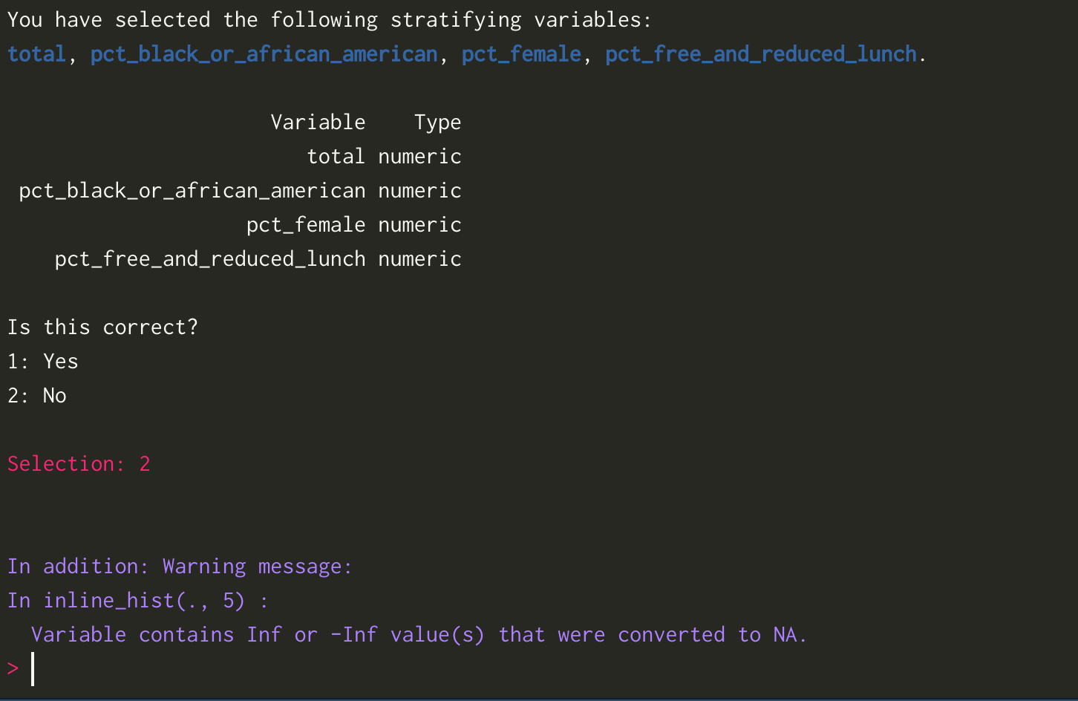

* I tried a new set of vars and selected “No” again. This closed the app. Should it return to the previous step to allow reselection?

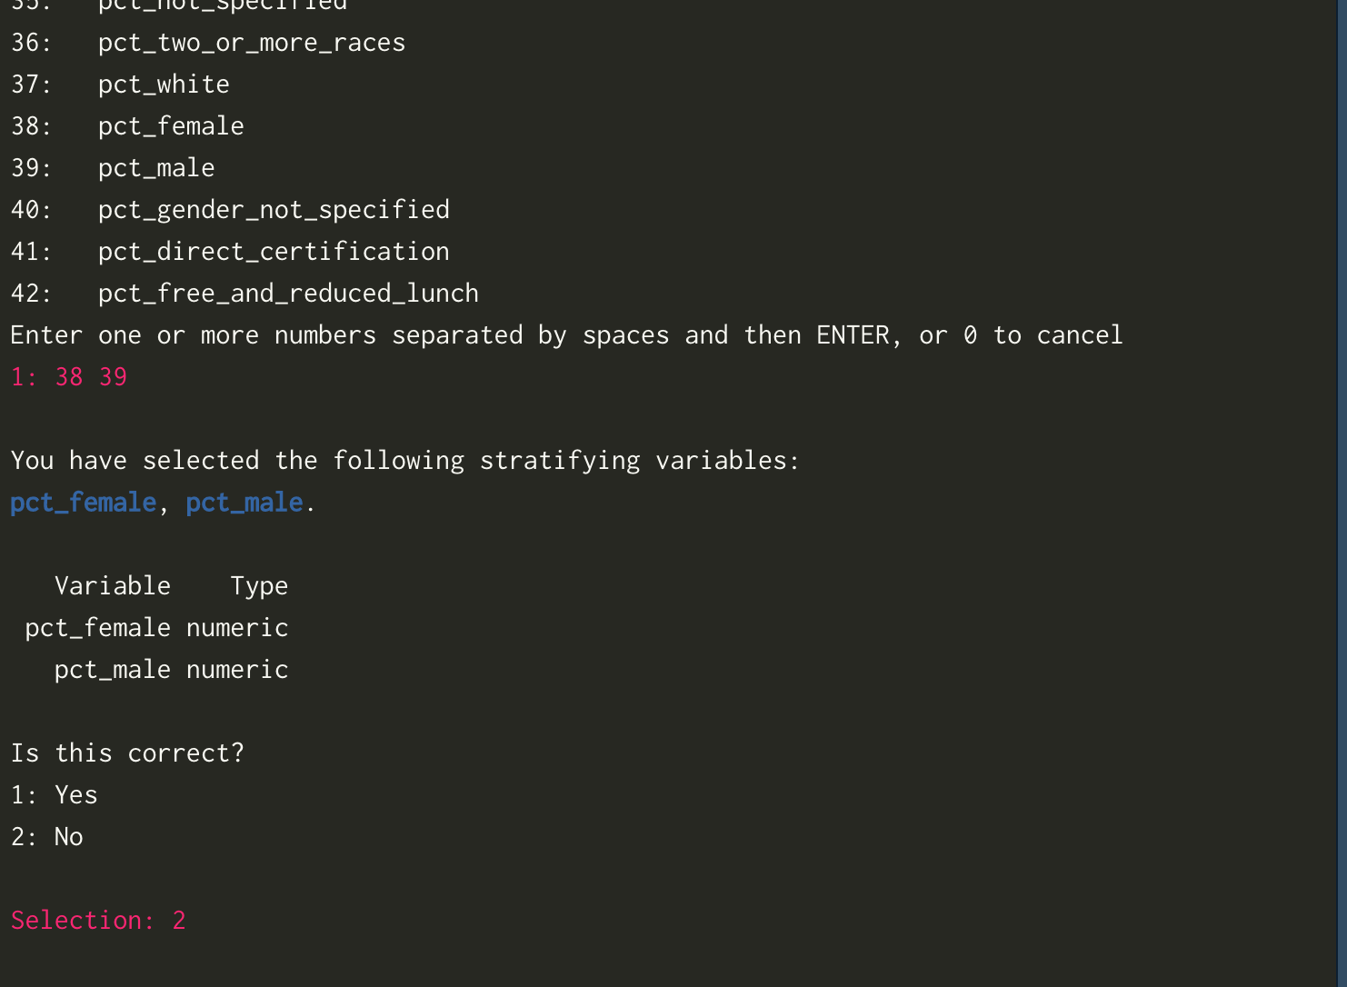

* I also tried selecting a different set of vars including a character var - and got this error. Do you need a warning here to make sure all stratification vars should be set categorical or continuous?

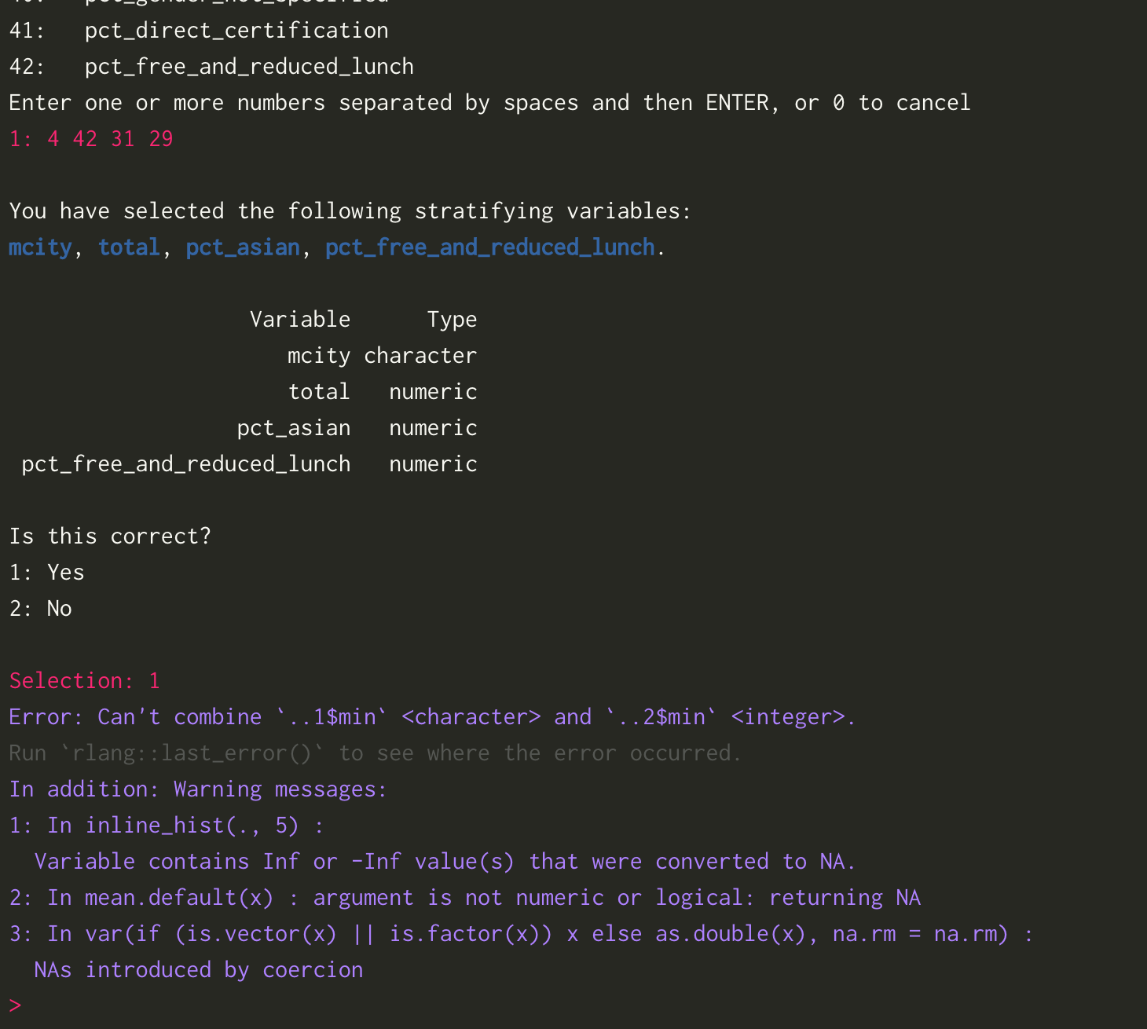

* I wondered if a url would be helpful on line 176 to the Generalizer web app
* The percentage variance explained sounds like a very useful metric here - I wondered if you wanted to add a reference so that users can cite it if needed?
* I followed the tutorial (example 1) with the same inputs, but got this error at the stratification stage. Interestingly, the non-guided example ran perfectly fine

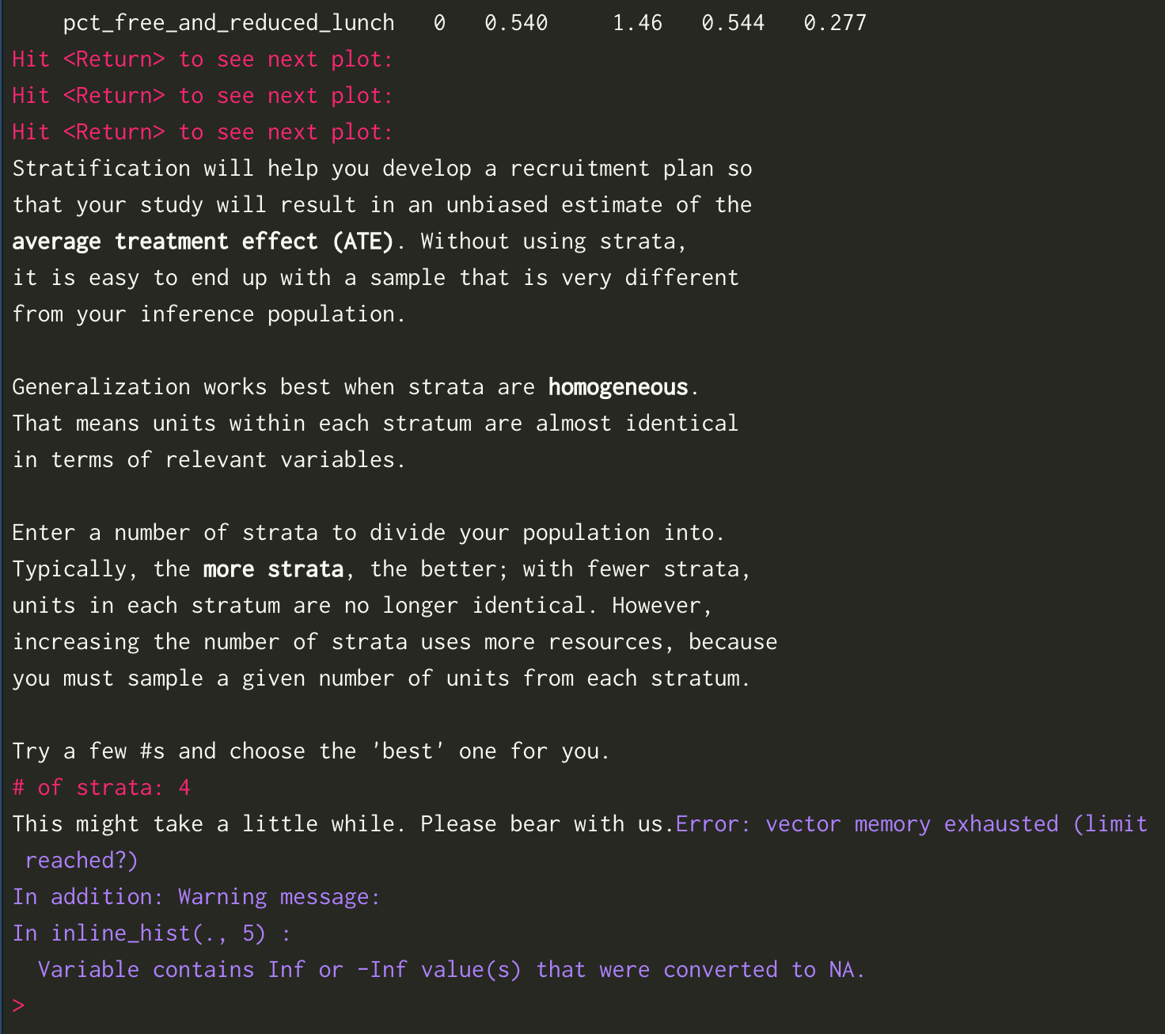

**recruit()**

* I tried saving the list as csv. It gave the following output, but I couldn’t find the file in the directory

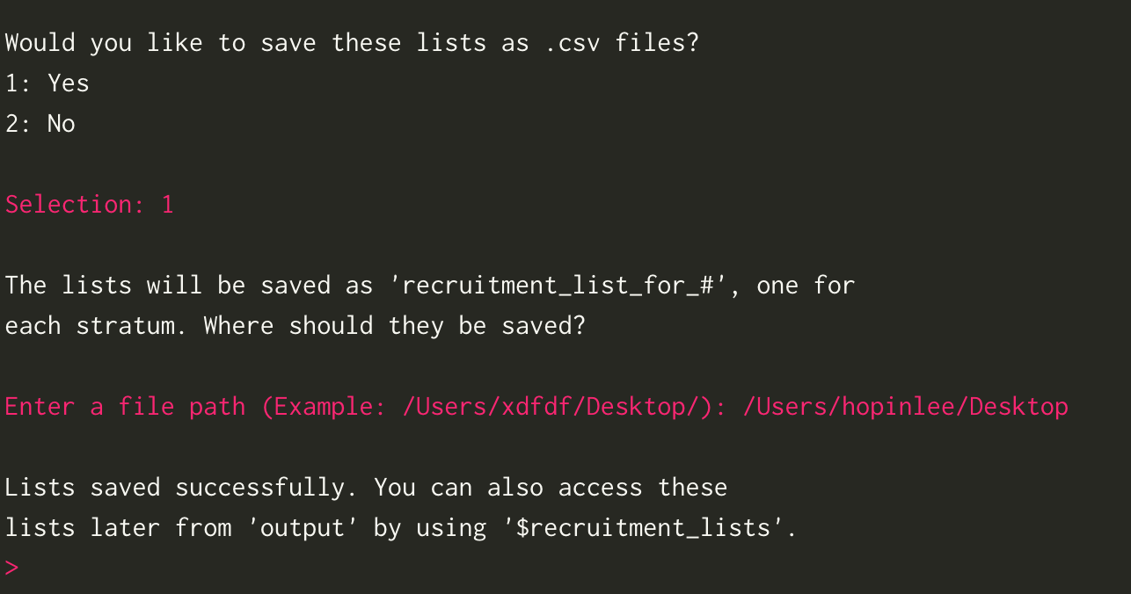

**assess()**

* Line 334 suggests that the df includes all charter high schools. However line 396 shows that some states do not have charter high schools. Would it be clearer for line 334 should say -- a df including all states with and without charter high schools?
* I’m guessing some arguments from the assess() function are hidden in the wrapper function. But does this need to be noted for the user in the tutorial or help doc?